Week_01

230701195

2025-01-25

print(sqrt(16))

## [1] 4

print(exp(2))

## [1] 7.389056

print(factorial(5))

## [1] 120

print(tanh(1.5))

## [1] 0.9051483

print(trunc(1.55))

## [1] 1

print(ceiling(1.55))

## [1] 2

print(log(2,base=10))

## [1] 0.30103

print(log(2))

## [1] 0.6931472

print(abs(-3))

## [1] 3

print(gmp::gcd(22,44))

## [1] 22

# Lineplot  
x <- seq(-10, 10, by = 0.1)  
y <- sin(x)  
plot(x, y, type = "l", col = "blue", main = "y = sin(x)", xlab = "x", ylab = "y")

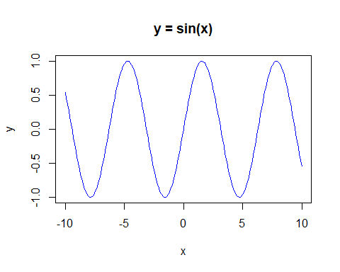

# Histogram  
random_numbers <- rnorm(1000)  
hist(random_numbers, main = "Histogram of Random Normal Numbers", xlab = "Value", col = "orange")

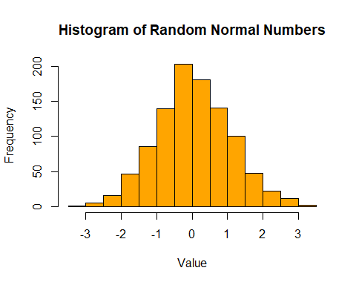

# Barplot  
fruits <- c("Apple", "Banana", "Cherry", "Date")  
counts <- c(10, 15, 7, 5)  
barplot(counts, names.arg = fruits, col = "green", main = "Fruit Counts", xlab = "Fruit", ylab = "Count")

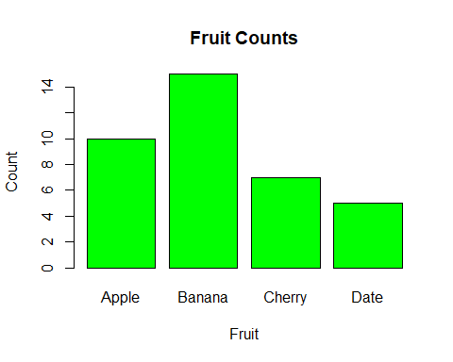

# Scatterplot  
x <- runif(20, 1, 10)  
y <- runif(20, 1, 10)  
plot(x, y, main = "Scatter Plot", xlab = "X values", ylab = "Y values", col = "red", pch = 16)

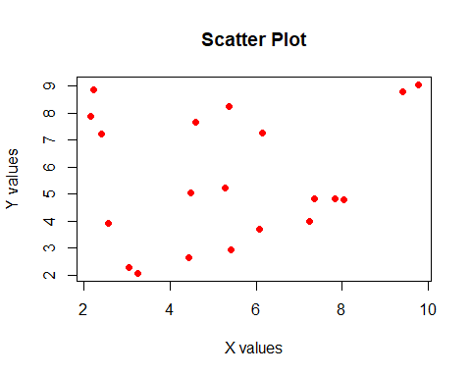

# Boxplot  
data <- rnorm(100)  
boxplot(data, main = "Boxplot of Random Data", ylab = "Values", col = "purple")

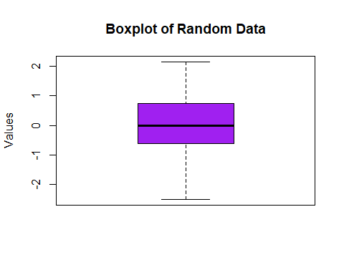

# Piechart  
sales <- c(20, 30, 25, 25)  
labels <- c("Q1", "Q2", "Q3", "Q4")  
pie(sales, labels = labels, col = rainbow(4), main = "Sales Distribution")

